International School-Conference
“Magnetic resonance and its applications – Spinus”
Abstract submission rules
Acceptable files
- The maximum number of pages is 3.
- Acceptable file formats: docx, doc, odt, rtf.
- The file of the abstract should be named as surname of the one of authors (preferably the speaker of the report) in Latin letters, for example, Ivanov.docx.
Figures, formulae and tables
- All figures and formulas must be inserted in the text of the abstract.
- Inserted figures should have enough resolution for printing (at least 150 dpi).
- Please do not insert figures in the form of embedded objects (ex.: Origin plots) because these images can be displayed incorrectly with the different version of application.
- Make sure that figures in color will be read correctly in gray-scale format.
Template
Please find the template below.
Application of novel double magic angle spinning (DMAS) technique to the fishing of Atlantic salmon
Salmonella Fisher, Boris I. Yachtman^{1,2}, Karl F. H. von Münchhausen³
¹Faculty of Fresh Water, Marine University, Great Icebergs in Northern Ocean
²Institute für Sail Sciences, Emerald City, OZ-16 131, Land of Oz
³Faculty of Physics, Polar Bear University, U-1001 Bear Lair, Ursa's Federation
E-mail: avtor@yourmail.ru
http://www.yoursite.ru
Introduction
Anton P. Chekhov, Russian writer, was an ardent fisherman and an avid reader of Leonid P. Sabaneyev's classic tome of Russian ichthyology, “Fishes of Russia: The Life and Fishing of Freshwater Fish” [1], which was reissued in 1882, shortly after Chekhov began his literary career.
Behaviour of Atlantic salmon
Atlantic salmon (Fig. 1) spawn in the fall. Like other members of the char group, the female digs a redd (nest) in the gravelly bottom, and deposits her eggs. Sometimes, the female will immediately swim downstream and build another redd and repeat the ritual.
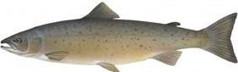
Figure 1. Atlantic salmon
Novel fishing technique
Magic angle definition
Well known formula defines so called “Magic angle”:
$$1-\frac{3\cos^{2}Θ_{M}}{2}=0,$$
where Θ_{M} is the angle between the vertical axis Z of Laboratory Frame, connected to Earth, and the long axis z of a spinning-rod. Magic angle Θ_{M} is equal to 54°44'8'', which is approximately corresponded to 0.3π.
Position of spinning rod and spinning reel
Spinning rod should have strong backbone [2]. The length of the rod may differ depend on country: in Britain it should be of 8½ feet length, in continental Europe – 2.5 m.
We tested several positions of the spinning rod while the fishing Atlantic salmon. The best position is shown in Fig. 2 (reproduced from [1]), where the angle between the vertical axis and the direction of the spinning rod is equal to Θ_{M}
Spinning reel should be designed so that the angle between the direction of spinning rod and the spindle of spool will be equal to Θ_{M}. Diameter of the spool may also vary in different countries (from 3 inch to 7.62 cm).
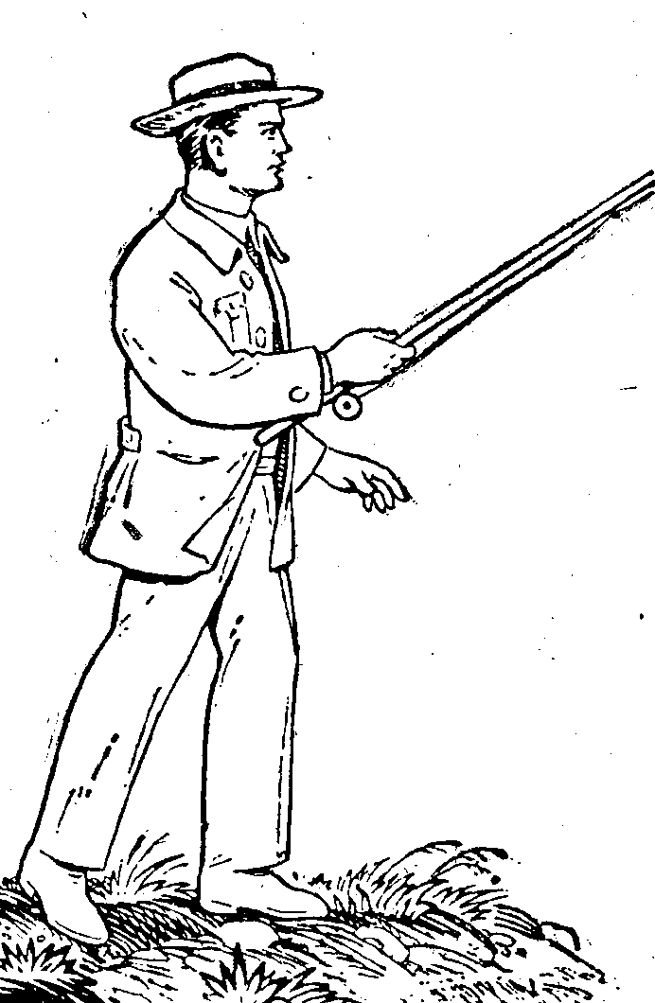
Figure 2. Position of a fisher and spinning rod (from [1])
Lures and terms
To fish the Atlantic salmon, the following types of lures are widely used:
- Artificial fly;
- Bait.
Some of useful terms are collected in the Table 1.
Table 1. Useful terms
Term | Explanation
Ecology | The branch of biology dealing with the relationship between organisms and their environment
Ichthyology | The branch of zoology that deals with fishes
Acknowledgements
This work is supported by the World Water Foundation (grant #05-04-03) and National Fishing Research (grant No. F-0405). L. N. thanks the Internet for high speed connection.
References
- L. P. Sabaneyev. The Life and Fishing of Freshwater Fishes (in Russian). – “Agriculture” Publ., Kiev, 1960.
- S. Fisher, B. I. Yachtman. – Vacuum State Comm., 7, 1234-1237 (2003).

